**FORT AUGUSTUS AND GLENMORISTON COMMUNITY COUNCIL**

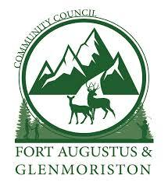

**Community Council Meeting on Wednesday, 30th April 2025**

**at the Millennium Hall, Invermoriston**

**AGENDA**

* Welcome and Apologies
* Previous draft minutes for approval
* Matters Arising

1. Community Assets - Inchnacardoch Slipway/Cherry Island Land, Kirton Memorial and land adjacent to school.

After previous discussions spanning over 18 months, the future of the assets owned by the Community Council will be decided at this meeting. The Assets are:

a) Land at Inchnacardoch Slipway/Cherry Island

b) Dr Kirton’s Memorial

c) Land adjacent to School

A review of the Options A and B are attached with the preferred outcome highlighted. Option C is the recommended disposal of land (land locked) by sale, the proceeds of which would be held in trust for the improvement of option A.

1. Community Interest Company Sub-committee

That the Community Council elect a sub-committee to handle the affairs of the transfer of ownership of assets and the subsequent organisation of the CIC. Consisting of 5 Community Councillors with up to 3 additional as directed by the CIC when active. All elected will form the Community Council representatives on the new CIC.

Those Community Councillors who have volunteered for the sub-committee and CIC (5) are:

James Prince

Dan Clark

Leanne Findlay

Mike Anderson

Jenny Findlay

1. Scottish Canals/BEAR/HC
2. Achnaconeran road

* Treasurer’s Report
* Community Company Report and Community Council Representative
* Renewable Energy Projects
* Planning and Licensing Applications
* Community Amenity Issues
* Correspondence
* AOCB